## *Chapter 1*

## INTRODUCTION

## 1.1 Background

Traffic Sign Recognition (TSR) represents a pivotal advancement in the field of intelligent transportation systems, aiming to enhance road safety and optimize traffic flow. With the rapid evolution of vehicular technology, including the rise of autonomous vehicles and advanced driver assistance systems (ADAS), the ability to interpret and respond to traffic signs becomes paramount. TSR involves the use of computer vision and machine learning techniques to automatically detect, recognize, and interpret traffic signs from visual data, typically captured by onboard cameras or other sensors.

### **1.1.1 Historical Context:**

Pre-Computer Vision Era: The concept of traffic signs has been present since the early days of motorized transportation. However, before the advent of computer vision, the interpretation of traffic signs was solely reliant on human drivers' visual perception and adherence to traffic rules.

Rule-Based Systems: Early attempts to automate TSR were often rule-based, involving predefined sets of rules and heuristics to recognize signs. These systems, while a step towards automation, were limited by their inability to adapt to diverse and dynamic real-world scenarios.

### **1.1.2 Technological Advances:**

The rise of computer vision as a field of study and the increasing computational capabilities of systems opened new avenues for tackling complex problems, including TSR. Computer vision technologies became instrumental in developing systems that could process visual information and make decisions in real-time. With the advent of machine learning, particularly deep learning techniques, TSR took a significant leap forward. Instead of relying on explicit rules , systems could now learn patterns and features from large datasets, enabling more robust and adaptive recognition capabilities.

## 1.2 Significance of TSR

The significance of TSR is deeply rooted in its potential to mitigate road accidents, reduce traffic violations, and streamline traffic management. Traditional traffic sign recognition relies on human drivers' visual acuity and cognitive abilities, which are prone to fatigue, distraction, or errors. By automating this process, TSR not only provides an additional layer of safety but also contributes to the broader vision of smart cities and efficient transportation networks.

## 1.3 Evolution of TSR Technologies

The journey of TSR technologies has witnessed a remarkable evolution. Early attempts relied on rule-based systems, where predefined rules and heuristics were used to interpret signs. However, the advent of computer vision and machine learning has revolutionized TSR, enabling systems to learn and adapt to diverse real-world scenarios. Modern TSR systems leverage deep learning, convolutional neural networks (CNNs), and sophisticated image processing techniques to achieve high accuracy in sign detection and classification.

## 1.4 Motivation

The motivation behind the development of robust TSR systems is multifaceted. Firstly, road safety is a global concern, and TSR serves as a proactive measure to prevent accidents caused by overlooked or misinterpreted traffic signs. Secondly, as cities grow and traffic density increases, efficient traffic management becomes essential. TSR contributes to this goal by providing real-time information about road conditions, restrictions, and warnings. Moreover, the rise of semi-autonomous and autonomous vehicles necessitates advanced TSR capabilities to ensure safe navigation in diverse environments.

**1.4.1**. **Motivations for Development:**

Road Safety Enhancement: One of the primary motivations for TSR development is the improvement of road safety. Accurate and timely recognition of traffic signs is crucial for preventing accidents caused by human error, distraction, or oversight.

Efficient Traffic Management: As urban areas grow and traffic congestion becomes a pressing issue, TSR plays a vital role in efficient traffic management. Providing real-time information about road conditions, speed limits, and warnings contributes to smoother traffic flow.

Autonomous Vehicles and ADAS: The advent of autonomous vehicles and Advanced Driver Assistance Systems (ADAS) amplifies the need for robust TSR. Autonomous vehicles rely heavily on visual data to navigate, and accurate recognition of traffic signs is fundamental to their safe operation.

## 1.5 Objectives of TSR

The primary objectives of a TSR system encompass accuracy, speed, and adaptability. The system must accurately recognize a wide range of traffic signs, including variations in shape, color, and text. Real-time processing is crucial to provide timely information to the vehicle's control system. Furthermore, the system should be adaptable to varying environmental conditions such as different lighting, weather, and road surface conditions.

Variability in Sign Designs: Traffic signs can vary widely in terms of shape, color, and text. Developing a system that can recognize this diversity is a persistent challenge.

Environmental Conditions: TSR systems must operate effectively under diverse environmental conditions, including different lighting, weather, and road surface conditions.

Real-Time Processing: Achieving real-time processing capabilities is crucial for TSR, especially in applications where timely responses are critical.

## 1.6 Scope of the Report

This report focuses on the implementation of a TSR system using the OpenCV library, a widely-used open-source computer vision library. OpenCV provides a versatile platform for image processing and computer vision tasks, making it well-suited for the challenges posed by TSR. The report will cover the entire pipeline, including data collection, preprocessing, feature extraction, model training, and evaluation.

## 1.7 Structure of the Report

The report is structured to provide a comprehensive understanding of the TSR implementation using OpenCV. Following this introduction, subsequent sections will delve into the methodology, detailing data collection, preprocessing techniques, feature extraction methods, model training, and evaluation metrics. The implementation using OpenCV will be thoroughly discussed, and the results will be presented and analyzed. Challenges faced during the project and avenues for future work will be outlined, followed by a conclusive summary.

In essence, this report aims to contribute to the growing body of knowledge in the domain of traffic sign recognition, providing insights into the practical implementation of a system that holds significant implications for the future of transportation and road safety.

***Chapter 2***

**LITERATURE SURVEY**

Literature survey is the most important step in software development process. Before developing the tool it is necessary to determine the time factor, economy and company strength. Once these things are satisfied, then the next step is to determine which operating system and language can be used for developing the tool. Once the programmers start building the tool the programmers need lot of external support. This support can be obtained from senior programmers, from book or from websites. Before building the system the above consideration are taken into account for developing the proposed system. The major part of the project development sector considers and fully survey all the required needs for developing the project. For every project Literature survey is the most important sector in software development process. Before developing the tools and the associated designing it is necessary to determine and survey the time factor, resource requirement, man power, economy, and company strength. Once these things are satisfied and fully surveyed, then the next step is to determine about the software specifications in the respective system such as what type of operating system the project would require, and what are all the necessary software are needed to proceed with the next step such as developing the tools, and the associated operations.

**2.1. Introduction to Traffic Sign Recognition:**

**Historical Context:**

Investigate the historical development of TSR, starting from early systems to contemporary approaches.

Explore how TSR has evolved with advancements in computer vision and machine learning.

**2.2 Image Processing and Computer Vision Techniques:**

**Feature Extraction:**

Review literature on different techniques for extracting features from traffic sign images.

Explore studies on color-based, shape-based, and texture-based feature extraction methods.

**Object Detection Algorithms:**

Examine the evolution of object detection algorithms applied to TSR, such as Haar cascades, Histogram of Oriented Gradients (HOG), and more recently, region-based CNNs (R-CNNs) and Single Shot Multibox Detectors (SSDs).

**Classification Algorithms:**

Explore studies on classification algorithms used in TSR, including traditional machine learning methods (e.g., Support Vector Machines) and deep learning architectures (e.g., CNNs).

**2.3. Machine Learning and Deep Learning Approaches:**

**Deep Learning Architectures:**

Investigate the use of various deep learning architectures like CNNs, Recurrent Neural Networks (RNNs), and attention mechanisms in TSR applications.

**Transfer Learning:**

Review research on the application of transfer learning in TSR, where pre-trained models on large datasets are adapted to traffic sign recognition tasks.

**2.4. Datasets for TSR:**

**Benchmark Datasets:**

Explore widely used benchmark datasets for TSR, such as the German Traffic Sign Recognition Benchmark (GTSRB) and others.

**2.5. Real-Time Systems and Hardware Implementation:**

**Embedded Systems:**

Investigate literature on implementing TSR in embedded systems, considering the computational constraints of real-time applications.

Explore studies on efficient algorithms and hardware architectures for real-time processing.

**2.6. Adverse Conditions and Challenges:**

**Adverse Weather Conditions:**

Examine research on TSR performance under adverse weather conditions, including rain, snow, and fog.

Investigate methods to enhance robustness in challenging environments.

**Occlusions and Partial Visibility:**

Review studies addressing the challenges posed by occluded or partially visible traffic signs.

**2.7. Integration with Autonomous Vehicles:**

**Perception in Autonomous Vehicles:**

Explore literature discussing how TSR contributes to the perception module of autonomous vehicles.

Investigate studies on the role of TSR in enhancing safety and decision-making in self-driving cars.

**2.8. Evaluation Metrics and Benchmarking:**

**Performance Metrics:**

Investigate commonly used metrics for evaluating TSR performance, such as accuracy, precision, recall, and F1 score.

Explore studies that propose new evaluation metrics or benchmarks.

**2.9. Recent Advances and Future Directions:**

**State-of-the-Art Approaches:**

Summarize recent advancements in TSR technology, including novel algorithms or architectures.

**Research Trends:**

Explore current research trends in TSR, such as the integration of TSR with other perception tasks or the application of TSR in novel domains.

**10. Regulatory and Standardization Aspects:**

**Regulatory Framework:**

Investigate literature discussing the regulatory aspects related to TSR, including standards and guidelines.

A comprehensive literature survey on traffic sign recognition (TSR) reveals the evolution of methodologies employed in this critical facet of intelligent transportation systems. Early approaches primarily relied on color-based segmentation and template matching, but these methods faced challenges related to lighting conditions and sign variations. The advent of feature extraction techniques, including Histogram of Oriented Gradients (HOG), Scale-Invariant Feature Transform (SIFT), and Local Binary Patterns (LBP), marked a transition towards more sophisticated algorithms. Machine learning algorithms, such as Support Vector Machines and Decision Trees, were subsequently introduced, leveraging handcrafted features for classification. However, the field witnessed a transformative shift with the rise of deep learning models, particularly Convolutional Neural Networks (CNNs), which demonstrated significant improvements in accuracy and robustness. Datasets like the German Traffic Sign Recognition Benchmark (GTSRB) played a pivotal role in training and evaluating these models. Performance evaluation metrics, including accuracy, precision, recall, and F1 score, have been instrumental in assessing the efficacy of TSR systems. Despite these advancements, challenges persist, such as occlusion and adverse weather conditions, prompting ongoing exploration of innovative solutions. The literature also highlights the broader applications of TSR, ranging from autonomous vehicles to smart cities and advanced driver-assistance systems. As researchers delve into these findings, they uncover a rich tapestry of knowledge, paving the way for future advancements in traffic sign recognition.

***Chapter 3***

**METHODOLOGY**

The methodology of Traffic Sign Recognition (TSR) typically involves a series of interconnected steps aimed at effectively detecting and classifying traffic signs within images or video streams. Initially, the process begins with image acquisition, where digital or camera-based systems capture the visual information of the road environment. Following this, preprocessing steps may be applied, including image resizing, color normalization, and noise reduction, to enhance the quality of the input data. The core of TSR lies in feature extraction, where distinctive characteristics of traffic signs, such as shape, color, and texture, are identified and highlighted. This step is crucial for reducing the dimensionality of the data and emphasizing relevant information for subsequent analysis.

Machine learning and deep learning techniques play a pivotal role in the methodology, particularly for the tasks of object detection and classification. Various algorithms, ranging from traditional methods like Support Vector Machines to more advanced convolutional neural networks (CNNs), are employed to recognize and interpret the extracted features. Training these models involves using annotated datasets containing images of traffic signs along with corresponding labels, allowing the algorithm to learn and generalize patterns. Transfer learning approaches may also be utilized, leveraging pre-trained models on large datasets for improved performance, especially in cases with limited labeled traffic sign data.

Real-time implementation is a crucial consideration in TSR, particularly for applications in autonomous vehicles or advanced driver assistance systems. Efficient algorithms and hardware architectures are explored to meet the computational demands of on-the-fly sign recognition. Moreover, addressing challenges related to adverse weather conditions, occlusions, and partial visibility is essential. Researchers often evaluate the performance of TSR systems using metrics such as accuracy, precision, and recall, benchmarking against established datasets to validate the effectiveness of their methodologies.

The integration of TSR into autonomous vehicles involves incorporating the recognition results into the broader perception module, contributing to the vehicle's understanding of its surroundings. Continuous research and development focus on improving the robustness, accuracy, and real-time processing capabilities of TSR methodologies, while also considering regulatory frameworks and standards to ensure safe and reliable deployment in real-world scenarios. Overall, the methodology of TSR is an interdisciplinary approach that combines image processing, machine learning, and real-time systems to enable automated recognition and understanding of traffic signs for enhanced road safety and intelligent transportation systems.

**3.1 Data Collection and Preprocessing:**

Gather a diverse dataset containing images of traffic signs under different scenarios (day, night, various weather conditions, etc.).Annotate the dataset with corresponding labels indicating the type of each traffic sign.

Preprocess the data, including resizing, normalization, and augmentation to enhance model robustness.

**3.2 Training the Model:**

Split the dataset into training, validation, and test sets. Train the selected model using the training set, optimizing for the chosen evaluation metrics.

Regularize the model to prevent overfitting and ensure generalization to unseen data.

**3.3 Documentation:**

Document the entire methodology, including dataset details, model architecture, training parameters, and performance results.

***Chapter 4***

**SYSTEM ANALYSIS**

**4.1 Purpose**

The purpose of this document is detection of traffic sign using machine learning algorithms. In detail, this document will provide a general description of our project, including user requirements, product perspective, and overview of requirements, general constraints. In addition, it will also provide the specific requirements and functionality needed for this project - such as interface, functional requirements and performance requirements.

**4.2 Scope**

The scope of this SRSdocument persists for the entire life cycle of the project. This document defines the final state of the software requirements agreed upon by the customers and designers. Finally at the end of the project execution all the functionalities may be traceable from the SRSto the product. The document describes the functionality, performance, constraints, interface and reliability for the entire life cycle of the project.

**4.3 Existing System**

Yuan et al. in which though the accuracy rate was high, the processing time was also very high. Another method used fusion network formation to obtain features of the signs and background statistics around the observed image, but the complexity was high.

**4.4 Disadvantages of exisisting system**

➢ Increased algorithms complexity

➢ Heavy system hardware requirement

➢ Different pre-processing for training data are necessary

**4.5 Proposed System**

Traffic sign recognition and detection is an important part of any autonomous vehicle. However, the real challenge lies in the detection and recognition of these traffic sign from the natural image in real time and with accuracy. This paper gives an overview of the traffic road sign detection and recognition system, we developed and implemented using an artificial neural network which is trained using real-life datasets. This paper presents the usage of convolution neural network along with dataset as an implementation of our project to attain real-time result with accuracy. The system developed based on this methodology can be implemented in public transports, personal cars, and other vehicles in order to keep drivers alert and reduce human errors that lead to accidents. The project has a wide implementation of selfdriving vehicles.

**4.6 Advantages Of Proposed System**

➢Reducing the number of accidents caused by driver distraction and to reduce the seriousness of such accidents.

➢Improve the driver's safety on the road.

**4.7 Data Flow Diagram**

1. The DFD is also called as bubble chart. It is a simple graphical formalism that can be used to represent a system in terms of input data to the system, various processing carried out on this data, and the output data is generated by this system.
2. The data flow diagram (DFD) is one of the most important modeling tools. It is used to model the system components. These components are the system process, the data used by the process, an external entity that interacts with the system and the information flows in the system.
3. DFD shows how the information moves through the system and how it is modified by a series of transformations. It is a graphical technique that depicts information flow and the transformations that are applied as data moves from input to output.
4. DFD is also known as bubble chart. A DFD may be used to represent a system at any level of abstraction. DFD may be partitioned into levels that represent increasing information flow and functional detail

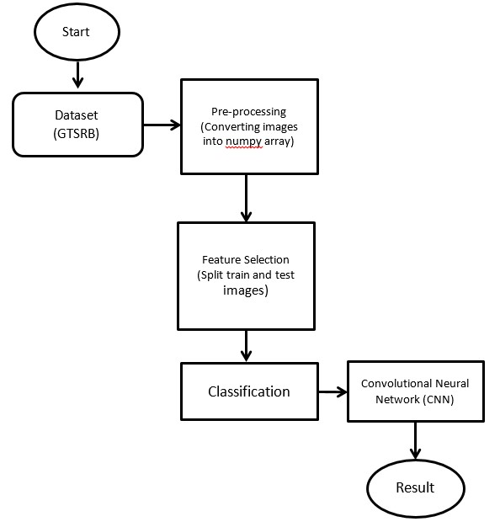

**Fig: 4.1 Data Flow Diagram**

**4.8 ER Diagram**

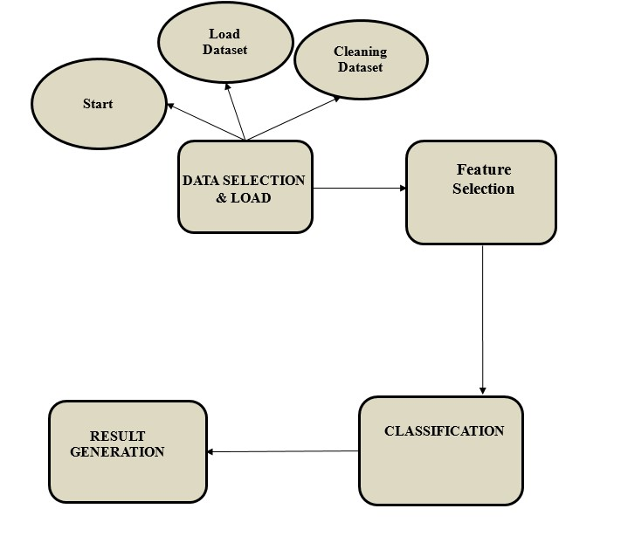

**Fig:4.2 ER Diagram**

**4.9 UML Diagrams**

UML stands for Unified Modeling Language. UML is a standardized generalpurpose modeling language in the field of object-oriented software engineering. The standard is managed, and was created by, the Object Management Group. The goal is for UML to become a common language for creating models of object oriented computer software. In its current form UML is comprised of two major components: a Meta-model and a notation. In the future, some form of method or process may also be added to; or associated with, UML. The Unified Modeling Language is a standard language for specifying, Visualization, Constructing and documenting the artifacts of software system, as well as for business modeling and other non-software systems. The UML represents a collection of best engineering practices that have proven successful in the modeling of large and complex systems. The UML is a very important part of developing objects oriented software and the software development process. The UML uses mostly graphical notations to express the design of software projects.

GOALS:

The Primary goals in the design of the UML are as follows:

1. Provide users a ready-to-use, expressive visual modeling Language so that they can develop and exchange meaningful models.
2. Provide extendibility and specialization mechanisms to extend the core concepts.
3. Be independent of particular programming languages and development process.
4. Provide a formal basis for understanding the modeling language.
5. Encourage the growth of OO tools market.
6. Support higher level development concepts such as collaborations, frameworks, patterns and components.
7. Integrate best practices.

**4.10 Use Case Diagram:**

A use case diagram in the Unified Modeling Language (UML) is a type of behavioral diagram defined by and created from a Use-case analysis. Its purpose is to present a graphical overview of the functionality provided by a system in terms of actors, their goals (represented as use cases), and any dependencies between those use cases. The main purpose of a use case diagram is to show what system functions are performed for which actor. Roles of the actors in the system can be depicted.

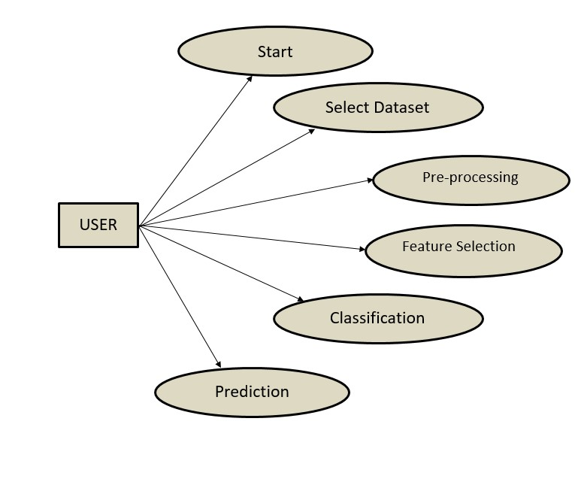

**Fig:4.3 Use Case Diagram**

**4.11 Sequence Diagram:**

A sequence diagram in Unified Modeling Language (UML) is a kind of interaction diagram that shows how processes operate with one another and in what order. It is a construct of a Message Sequence Chart. Sequence diagrams are sometimes called event diagrams, event scenarios, and timing diagrams.

Each arrow represents a message or communication between different components at different stages of the sequence. Note that the actual sequence diagram may involve more detailed interactions and additional components depending on the specific architecture and functionalities of the TSR system.

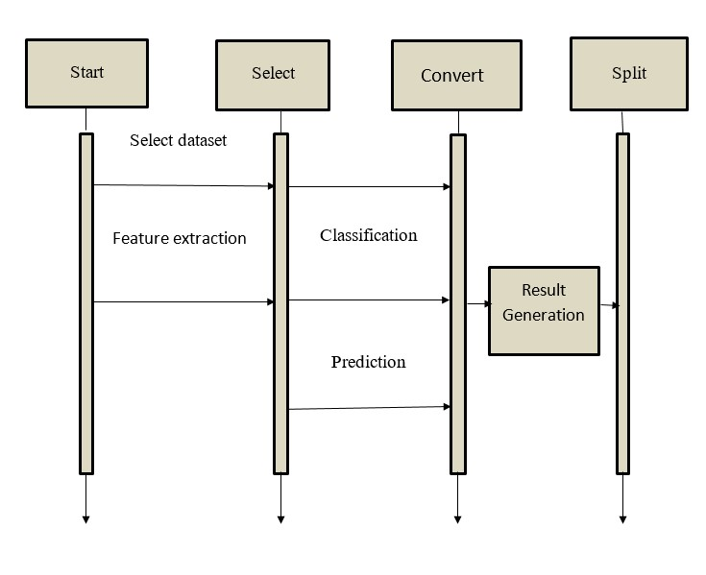

**Fig: 4.4 Sequence Diagram**

**4.12 Activity Diagram:**

Activity diagrams are graphical representations of workflows of stepwise activities and actions with support for choice, iteration and concurrency. In the Unified Modeling Language, activity diagrams can be used to describe the business and operational step-by-step workflows of components in a system. An activity diagram shows the overall flow of control.

The process begins with the "Start Activity" and progresses through various activities, including data collection, pre-processing, model training, optimization, evaluation, deployment, real-time inference, monitoring, and maintenance.

Each activity is represented by a rounded rectangle, and the arrows indicate the flow of control between activities.

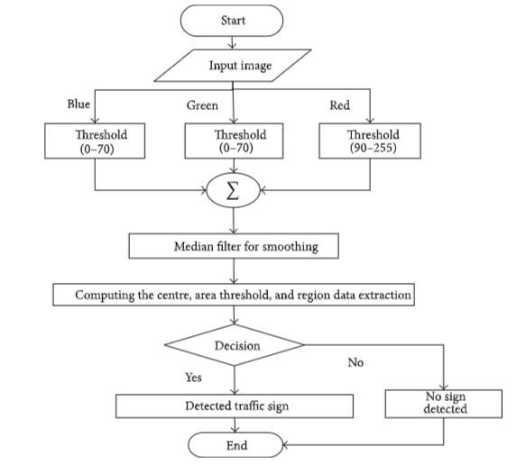

**Fig: 4.5 Activity Diagram**

The "End Activity" signifies the completion of the TSR system's activities.

This diagram provides a high-level overview of the sequential flow of activities in a Traffic Sign Recognition system, from the initial data collection to ongoing maintenance and monitoring. The specifics of each activity can be further detailed in subsequent diagrams or documentation.

***Chapter 5***

**MODULES DESCRIPTION**

**5.1 Modules**

* Segmentation Module
* Data Pre-processing
* Traffic Sign-Recognition
* Traffic Sign-Detection

**5.2 Module Description**

**5.2.1 Segmentation Module**

Segmentation is the method of partitioning a visual image into different subgroups (of pixels) called Image Objects, which reduces the image's complexity and makes image analysis easier. Thresholding is the method of using an optimal threshold to transform a grayscale input image to a bi-level image.

**5.2.2 Data Pre-Processing Module**

To save space or reduce computing complexity, we can find it helpful to remove redundant details from images in some situations. .Converting colorful images to grayscale images, for example. This is because color isn't always used to identify and perceive an image in several objects. Grayscale may be sufficient for identifying such artefacts. Color images can add needless complexity and take up more memory space because they hold more detail than black and white images color images are represented in three channels, which means that converting it to grayscale reduces the number of pixels that need to be processed. For traffic signs gray values are sufficient for recognition.

**5.2.3 Traffic Sign-recognition Module**

Deep Learning is a subdomain of Machine Learning that includes Convolutional Neural Networks. Deep Learning algorithms store information in the same manner as the human brain does, but on a much smaller scale .Image classification entails extracting features from an image in order to identify trends in a dataset. We are using CNN for traffic sign recognition as it is very good at feature extraction. In CNN, we use filters. Filters come in a variety of shapes and sizes, depending on their intended use. Filters allow us to take advantage of a specific image's spatial localization by imposing a local communication pattern between neurons. Convolution is the process of multiplying two variables pointwise to create a new feature. Our image pixels matrix is one function and our filter is another. The dot product of the two matrices is obtained by sliding the filter over the image. Matrix called "Activation Map" or "Feature Map". The output layer is made up of several convolutional layers that extract features from the image. CNN can be optimized with the help of hyper parameter optimization. It finds hyper parameters of a given machine learning algorithm that deliver the best performance as measured on a validation set. Hyper parameters must be set before the learning process can begin. The learning rate and the number of units in a dense layer are provided by it. In our system will consider dropout rate, learning rate, kernel size and optimizer hyper parameter.

**5.2.4 Traffic Sign Detection Module**

In this Module, we have addressed the problem of detecting and recognizing a large number of traffic-sign categories for the main purpose of automating traffic-sign inventory management. Due to a large number of categories with small interclass but high intra-class variability, we proposed detection and recognition utilizing an approach based on the Mask RCNN detector. The system provides an efficient deep network for learning a large number of categories with an efficient and fast detection.

In the Traffic Sign Recognition (TSR) system, several interconnected modules collaborate to achieve effective recognition of traffic signs. The initial phase involves the Data Acquisition Module, responsible for assembling a diverse and well-labeled dataset from existing sources like GTSRB or by creating a custom dataset. Subsequently, the Data Pre-processing Module takes charge of preparing the dataset for model training, incorporating tasks such as image resizing, pixel value normalization, and data augmentation. Feature extraction, inherent to deep learning models like Convolutional Neural Networks (CNNs), automatically identifies relevant patterns during the Model Training Module, where the dataset is split into training, validation, and test sets for optimization. The Model Optimization Module fine-tunes hyperparameters and regularization techniques to enhance the model's generalization ability. Model Evaluation follows, assessing performance metrics on a separate test set. Upon achieving satisfactory results, the Deployment Module integrates the model into real-world applications, such as mobile apps or web platforms. The Inference Module handles real-time predictions on new data efficiently, meeting the requirements of applications like autonomous vehicles. Continuous Monitoring and Maintenance ensure ongoing optimal performance, with periodic retraining based on changes in traffic sign appearances. Optionally, a User Interface Module may be implemented to present recognized signs to users, providing additional information or warnings. Together, these modules form a comprehensive framework for the successful implementation of a Traffic Sign Recognition system, encompassing data processing, model training, deployment, and user interaction.

***Chapter 6***

**SYSTEM IMPLEMENTATION**

**6.1 System Architecture**

Describing the overall features of the software is concerned with defining the requirements and establishing the high level of the system. During architectural design, the various web pages and their interconnections are identified and designed. The major software components are identified and decomposed into processing modules and conceptual data structures and the interconnections among the modules are identified. The following modules are identified in the proposed system.

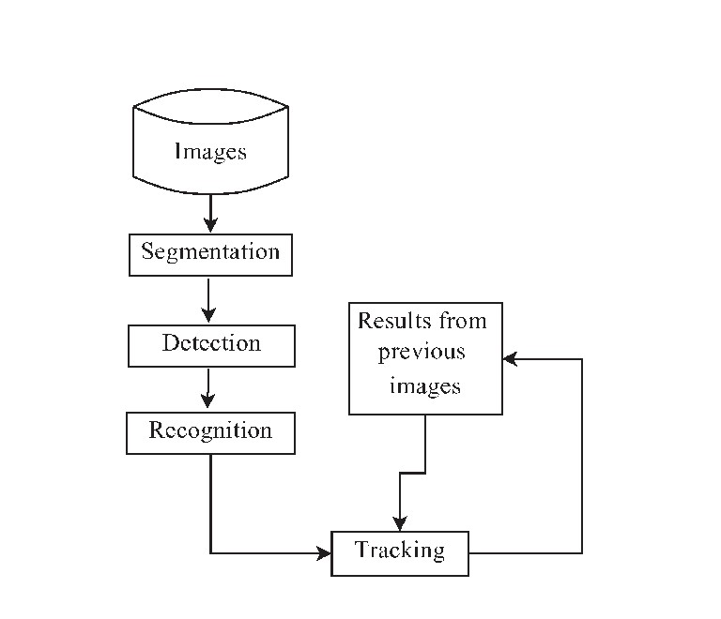

**Fig:6.1 System Architecture**

The above architecture describes the work structure of the system. The data is collected and image processing is done after pre-processing. After completing the pre-processing with the collected data and then by applying machine learning algorithms it detects and recognizes the traffic signal.

**6.2 Problem Statement:**

Automatic detection and recognition of traffic signs plays a crucial role in management of the traffic-sign inventory. The issue of detecting and recognizing a large number of traffic-sign categories suitable for automating traffic-sign inventory management. We adopt a convolutional neural network (CNN) approach, the mask R-CNN, to address the full pipeline of detection and recognition with automatic end to-end learning. We propose several improvements that are evaluated on the detection of traffic signs and result in an improved overall performance.

Implementing a traffic sign recognition system involves a comprehensive process that spans from data collection to system deployment. The initial step entails defining the problem and specifying the scope of the recognition task. Subsequently, a diverse and well-label dataset of traffic sign images must be collected, either from existing datasets like GTSRB or by creating a custom dataset. Data pre-processing is then crucial, involving tasks such as resizing images, normalizing pixel values, and augmenting the dataset for improved model generalization.

The heart of the system lies in selecting an appropriate deep learning model, commonly a Convolutional Neural Network (CNN), tailored for image recognition. Model training follows, utilizing a training set for the actual training process and a validation set for hyperparameter tuning. Evaluation metrics such as accuracy, precision, recall, and F1 score are employed to assess the model's performance on a separate test set.

Optimization becomes a key phase where hyperparameters and regularization techniques are fine-tuned to enhance the model's effectiveness. Once a satisfactory performance is achieved, the model is deployed for real-world applications, potentially integrated into mobile apps, web platforms, or dedicated devices. In the deployment phase, the efficiency of the inference mechanism is crucial, especially for real-time applications. Continuous monitoring and, if necessary, periodic retraining with new data ensure that the system adapts to changing conditions or variations in traffic sign appearances over time.

The implementation may also involve creating a user interface, depending on the application, to present recognized traffic signs to users with additional information or warnings. Ethical considerations, safety precautions, and compliance with legal and privacy regulations are paramount throughout the entire process, particularly when dealing with traffic-related data. Overall, the successful implementation of a traffic sign recognition system requires a holistic approach encompassing technical, ethical, and legal dimensions.

**Environment Setup:**

Establish the development environment with necessary tools, libraries, and frameworks such as TensorFlow, PyTorch, or OpenCV. Ensure compatibility with hardware specifications, especially if deploying on edge devices or in real-time scenarios.

**Data Collection and Preprocessing:**

Collect a comprehensive dataset of traffic sign images, ensuring diversity in terms of lighting, weather, and sign variations. Annotate the dataset with corresponding labels indicating the type of each traffic sign.

Implement data preprocessing steps, including resizing, normalization, and augmentation to enhance model training.

**Deployment:**

Integrate the trained model into the target system, whether it's an autonomous vehicle, smart traffic management system, or an advanced driver-assistance system. Ensure compatibility with the target hardware and implement necessary interfaces for data input and output.

**Continuous Monitoring and Updating:**

Implement mechanisms for continuous monitoring of the TSR system's performance in real-world scenarios. Establish a process for updating the model periodically using new data to adapt to changing conditions and improve accuracy over time.

***Chapter 7***

**EXPERIMENTAL RESULTS**

**7.1 Distribution Of Traning Datasets**

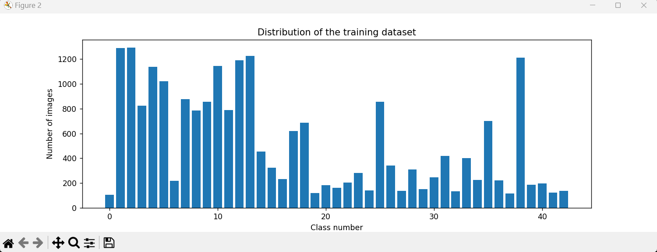

**Fig. 7.1 Distribution Of Traning Datasets**

In the context of traffic sign recognition, the distribution of the training dataset is crucial for developing an effective and robust model. The distribution should reflect the real-world scenario in terms of the types and frequencies of traffic signs

Split the dataset into training, validation, and test sets carefully. Random splitting or stratified splitting can be used to ensure that each set has a representative distribution of traffic signs. Ensure that the dataset has a balanced representation of different traffic sign classes. Each type of traffic sign (e.g., stop signs, speed limit signs, yield signs) should be well-represented in the training data. This helps the model learn equally from each class and prevents biases toward more frequently occurring signs.

**7.2 Preprocesed Images**

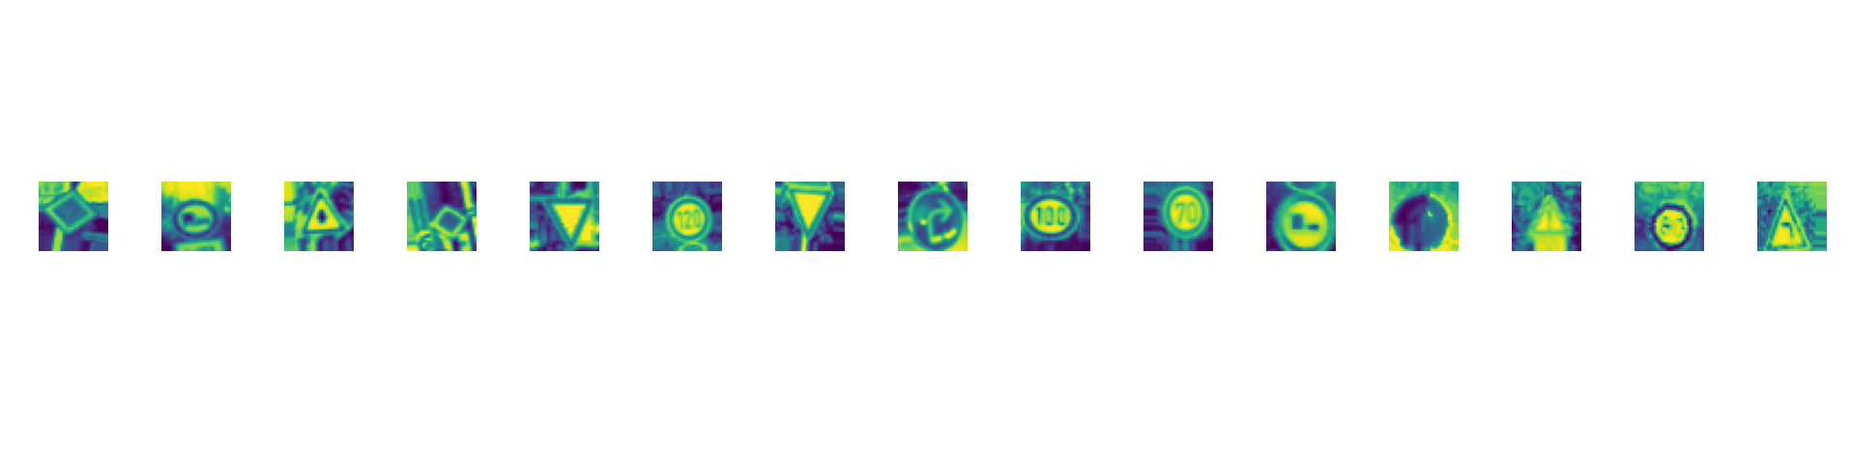

**Fig. 7.2 Preprocesed Images**

Convert images to a different color space if necessary. For instance, converting images from RGB to grayscale can simplify the model while preserving important information for recognition. Apply data augmentation techniques such as rotation, scaling, flipping, and translation. Augmentation increases the diversity of the training set, helping the model generalize better to different situations.

**7.3 Accuracy In Epochs**

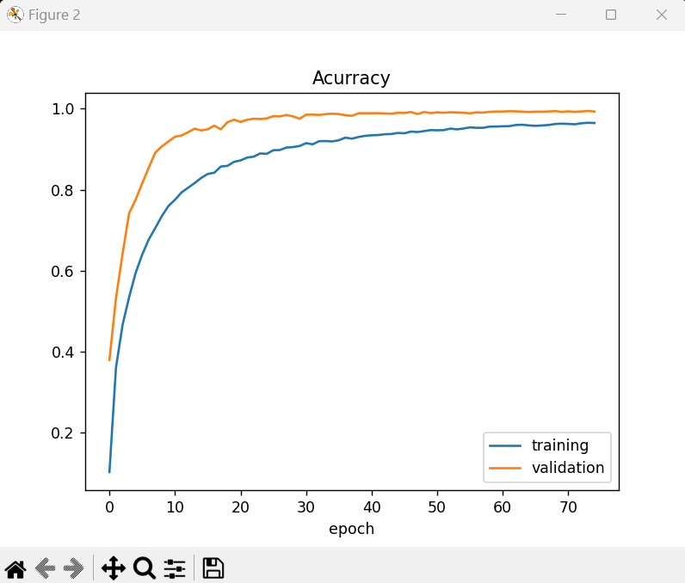

**Fig. 7.3 Accuracy In Epochs**

**7.4 Loss In Epochs**

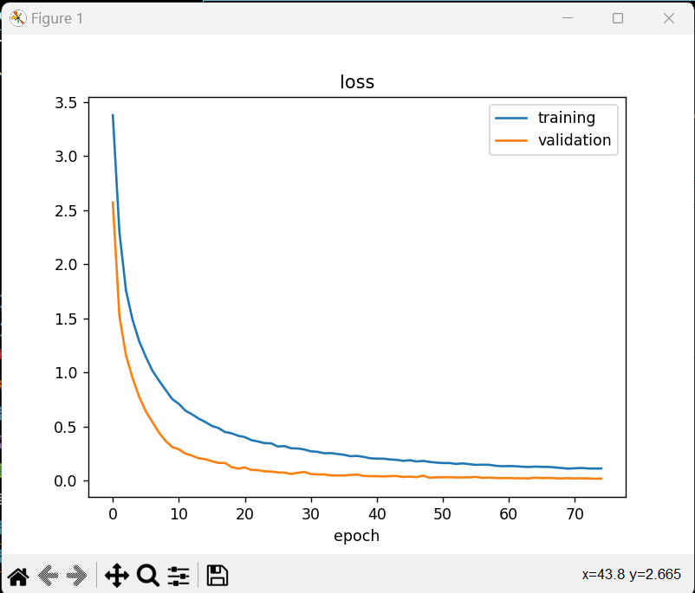

**Fig. 7.4 Loss In Epochs**

**7.5 Output of Traffic Sign Recognition**

**7.5.1 Bumpy Road Image**

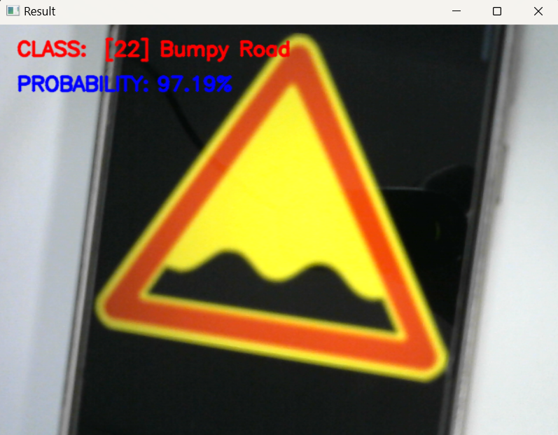

**Fig. 7.5 Bumpy Road Image**

Above image shows the traffic sign of bumpy road with 97.19 % probability.

**7.5.2 Dengerous Curve To The Left Image**

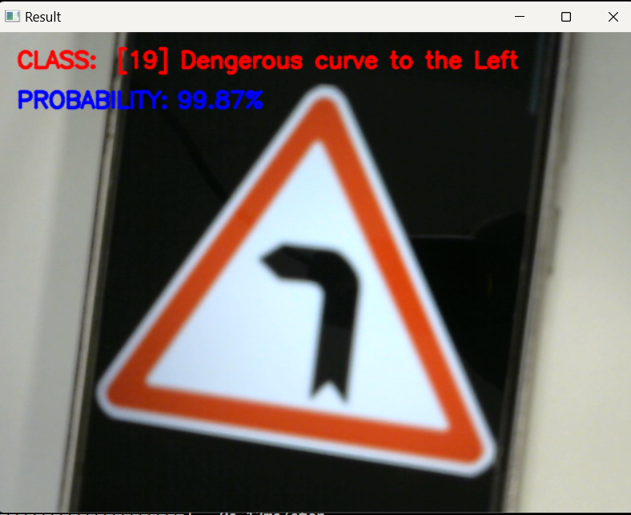

**Fig.7.6 Dengerous Curve To The Left Image**

Above image shows the traffic sign of dengerous curve to the left with 99.87 % probability.

**7.5.3 End of Speed Limit 80 km/h**

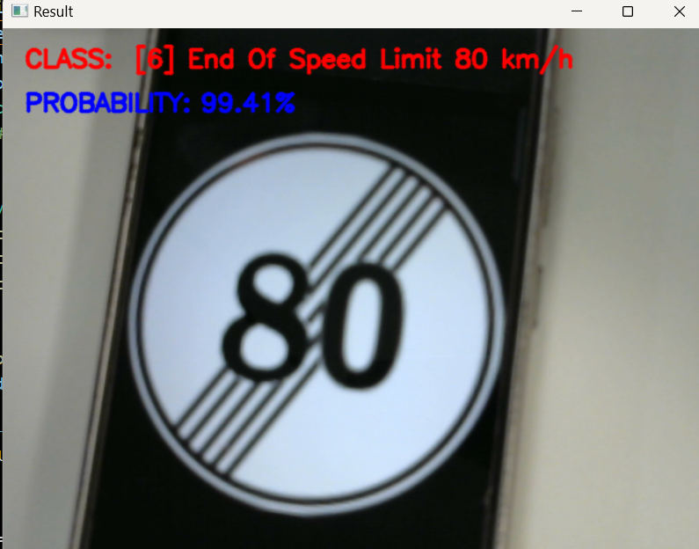

**Fig. 7.7 End of Speed Limit 80 km/h Image**

Above image shows the traffic sign of end of speed limit 80 km/h with 99.41 % probability.

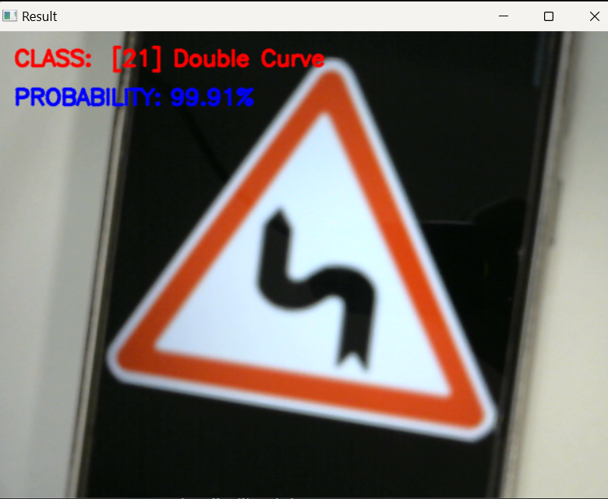**7.5.4 Double Curve**

**Fig. 7.8 Double Curve Image**

Above image shows the traffic sign of double curve with 99.91 % probability.

**7.5.5 No Entry**

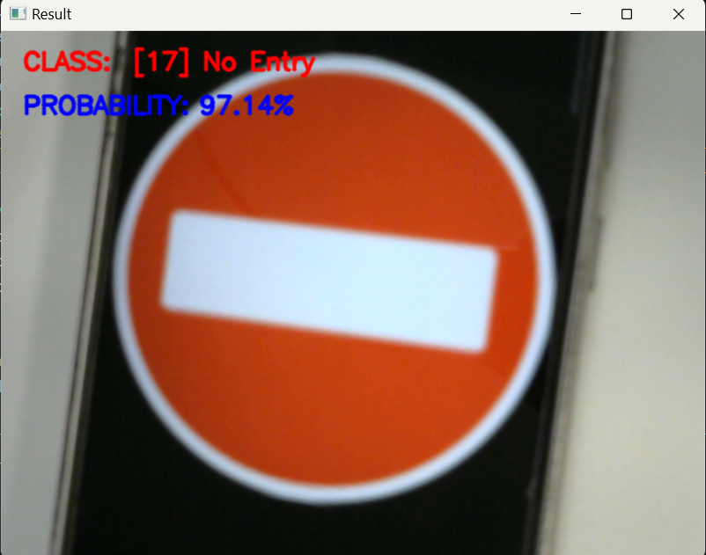

**Fig. 7.9 No Entry Image**

Above image shows the traffic sign of no entry with 97.14 % probability.

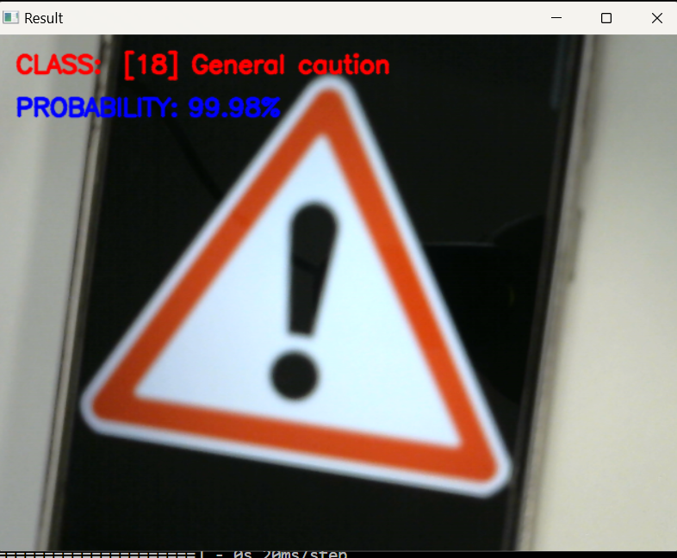**7.5.6 General Caution**

**Fig. 7.10 General Caution Image**

Above image shows the traffic sign of general caution with 99.98 % probability.

**7.5.7 Speed Limit 80 km/h**

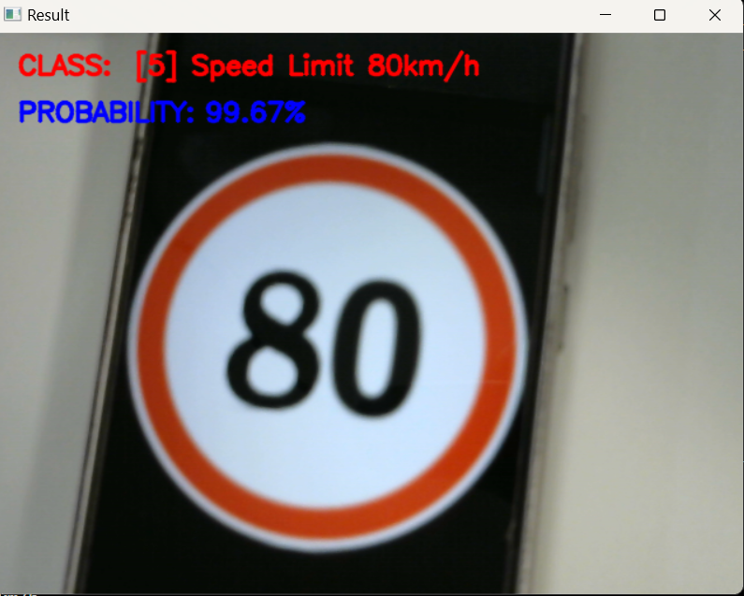

**Fig. 7.11 Speed Limit 80 km/h Image**

Above image shows the traffic sign of speed limit 80 km/h with 99.67 % probability.

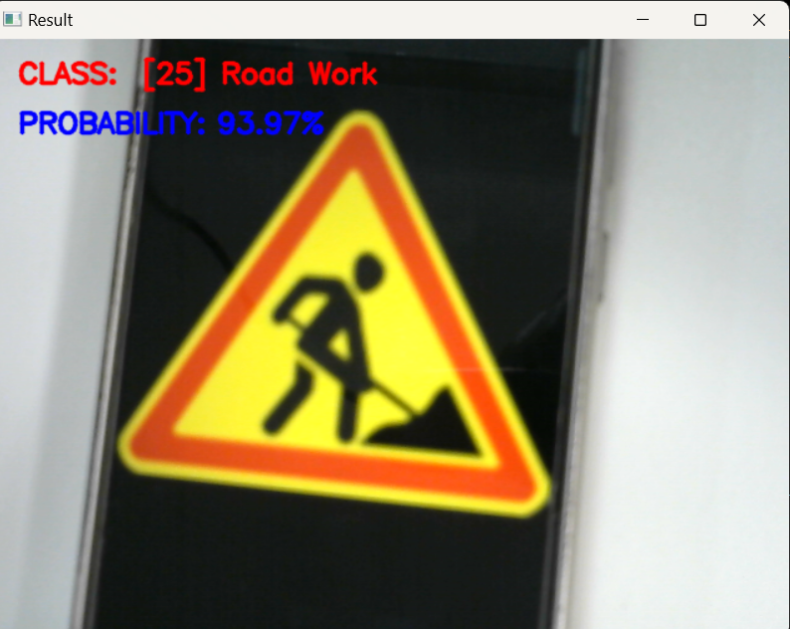**7.5.8 Road Work**

**Fig.7.12 Road Work Image**

Above image shows the traffic sign of road work with 99.67 % probability.

**7.5.9 Speed Limit 70 km/h**

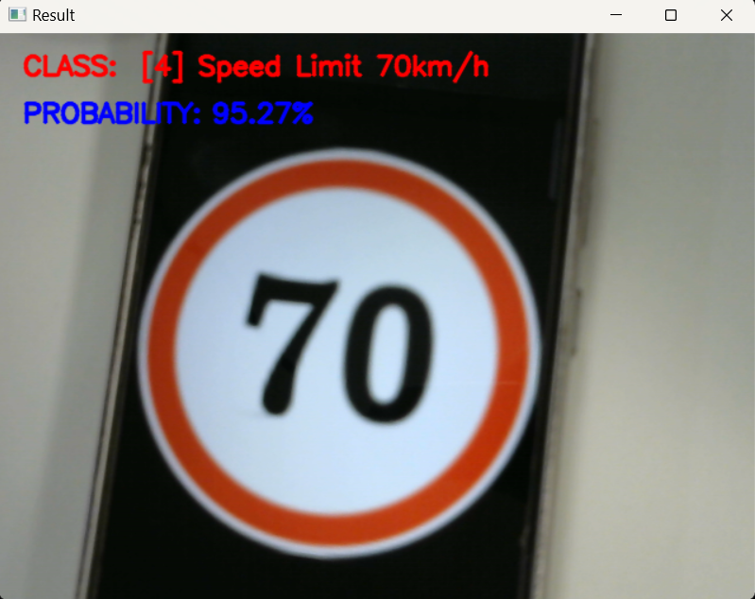

**Fig. 7.13 Speed Limit 70 km/h Image**

Above image shows the traffic sign of speed limit 70 km/h with 95.27 % probability.

**7.5.10 Stop**

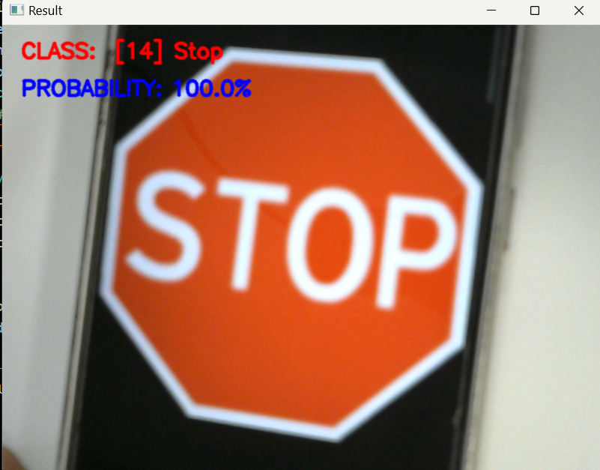

**Fig. 7.14 Stop Image**

Above image shows the traffic sign of stop with 100.0 % probability.

**7.5.11 Traffic Signals**

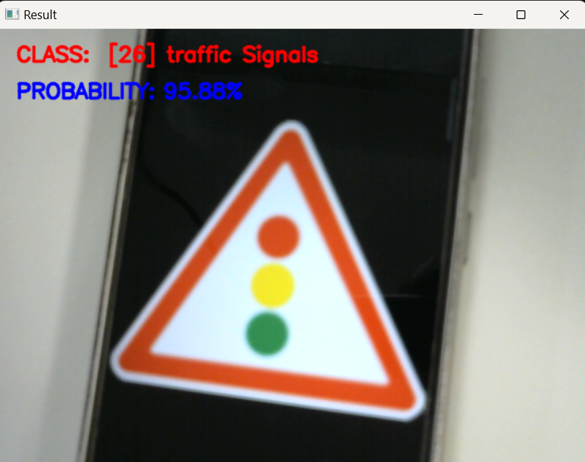

**Fig. 7.15 Traffic Signals Image**

Above image shows the traffic sign of traffic signals with 95.88 % probability.

**CONCLUSION**

The implementation of a Traffic Sign Recognition (TSR) system is a multifaceted process that integrates various modules and activities to achieve accurate and efficient recognition of traffic signs. The system begins with data acquisition, where a diverse dataset of label images is collected, either from existing datasets or by creating a custom dataset. Data pre-processing follows, involving tasks such as resizing, normalization, and augmentation to prepare the data for model training.

The selection of a suitable deep learning model, typically a Convolutional Neural Network (CNN), and its subsequent training and optimization are critical steps in ensuring the system's effectiveness. Model evaluation, using metrics like accuracy and precision, provides insights into its performance on a test dataset. Once the model meets the desired criteria, it is deployed for real-world applications, requiring integration into platforms such as mobile applications or web services. Real-time inference on new data is a core function of the deployed system, and continuous monitoring is essential to ensure optimal performance. Periodic maintenance, including retraining with new data to adapt to changes in traffic sign appearances, further enhances the system's longevity and adaptability.

**REFERENCES**

1. Aziz S, Mohamed E, Youssef F “Traffic sign recognition based on multifeature fusion and ELM classifier”, Proc Computer Sci 127:146–153(2018).
2. Jang, C., Kim, H., Park, E., Kim, H. “Data debiased traffic sign recognition using MSERs and CNN”, In 2016 International Conference on (2016).
3. Electronics, Information, and Communications (ICEIC), Da Nang, Vietnam, pp.
4. Lai, Y., Wang, N., Yang, Y., & Lin, L “Traffic signs recognition and classification based on deep feature learning”, In 7th International Conference on Pattern Recognition Applications and Methods (ICPRAM), Madeira, Portugal (2018).
5. Rosario G, Sonderman T, Zhu X, “Deep Transfer Learning for Traffic Sign Recognition[C]”, IEEE International Conference on Information Reuse and Integration (IRI). IEEE: 178–185. MLA (2018).
6. Huang, Z., Yu, Y., Gu, J., & Liu, H, “An efficient method for traffic sign recognition based on extreme learning machine” ,IEEE transactions on cybernetics (2017).
7. Li, C., Hu, Y., Xiao, L, Tian, L, “Salient traffic sign recognition based on sparse representation of visual perception” , In 2012 International Conference on Computer Vision in Remote Sensing, Xiamen (2012).